

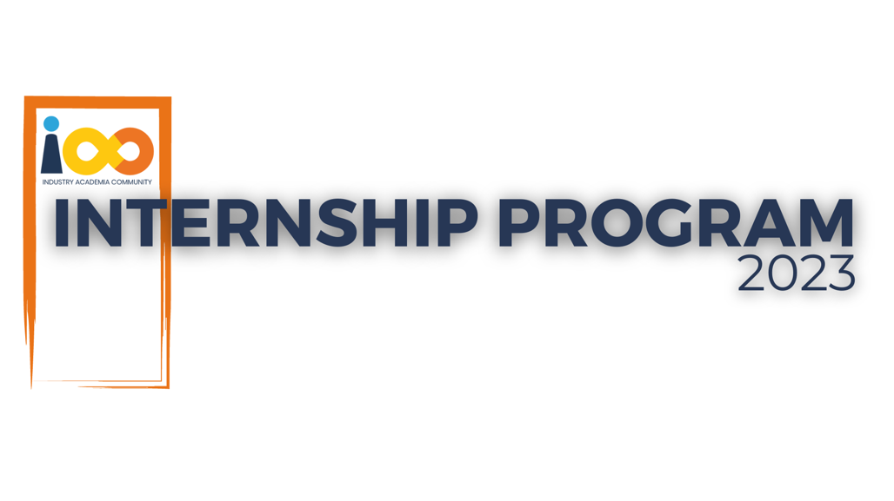

PROJECT REPORT

Web Development  
  
FindMyCampus

|  |  |  |  |
| --- | --- | --- | --- |
| **Created By:** | Sivakumar Thevar | **Approved By:** | Jonathan Dabre |
| **Created On:** | 23-04-2024 | **Approved On:** | 30-04-2024 |

Page left blank intentionally

**INDEX**

**1** **PROJECT DETAILS** 2

**2** **SUMMARY** 2

**3** **INTRODUCTION** 3

3.1 Background 3

3.2 Stakeholders 3

3.3 Objectives 4

**4** **METHODOLOGY** 4

4.1 Considerations & Assumption 4

4.2 Approach 5

4.3 Activities 5

**5** **TARGETTED V/S ACHIEVED OUTPUT** 5

**6** **CONCLUSION** 6

**7** **APPENDICES** 8

7.1 Appendix A – Detailed Description of Components 8

7.2 Appendix B – Detailed Description of Tables……………………...………….10

**General Instructions for using the Live Project Report Template**

* This template and the subsequent document created using this template is a confidential document and is the intellectual property of Cloud Counselage Pvt. Ltd. Circulating it outside of the organisation without the consent of Cloud Counselage Pvt. Ltd. is the breach of company policies and will lead to legal actions
* This template is a guideline document to communicate the implementation of design ideas and the results of the work to the stakeholders.
* The **text between inequality (< >) is to be replaced** by relevant text
* Please **remove the yellow highlight on the Text** between the inequality (< >). This is done to help you notice the text to be changed/replaced
* The text in *italics* highlighted in grey is just for reference and should be removed after adding the relevant text

# **PROJECT DETAILS**

|  |  |  |  |
| --- | --- | --- | --- |
| **Project Name** | FindMyCampus | | |
| **Project Sponsor** | Tushar Topale | | |
| **Project Manager** | Harshada Topale | | |
| **Start Date** | 07-02-2024 | **Completion Date** | 30-04-2024 |

# **SUMMARY**

There is an absence of an efficient and user-friendly online platform for prospective students in India to search and discover colleges. The existing resources are scattered, outdated, and insufficient in providing comprehensive details about colleges and the courses they offer. Students searching for colleges online face challenges due to excessive advertisements, which hinder their ability to make well-informed decisions about their education.

There is a significant lack of a centralized platform where students can easily search for and discover colleges. Comprehensive information about courses, contact details, and other relevant details is not readily available. The current situation makes it difficult for students to navigate the college selection process effectively.

The proposed application addresses the lack of a centralized platform for college search and discovery in India. By providing accurate and reliable information about colleges and courses, it empowers students to make informed decisions. Additionally, this platform could facilitate partnerships between Cloud Counselage and colleges, benefiting students in their professional development.

The proposed solution is to build a web application with a backend database containing information about IT and management colleges in India, along with other institutions offering relevant courses. In summary, the proposed solution aims to create an efficient and user-friendly platform that simplifies college search, empowers students, and fosters collaboration between Cloud Counselage and educational institutions.

# **INTRODUCTION**

## Background

There is a significant lack of a centralized platform for students to search and discover colleges, along with comprehensive details of the courses they offer.

Existing resources are scattered, and some are outdated or insufficient in providing the necessary information.

When searching for colleges online, students are bombarded with advertisements, making it difficult for them to make well-informed decisions about their education.

A platform that provides students with accurate and reliable information about colleges, courses offered, and contact details without any persuasive tactics would be immensely beneficial.

## Stakeholders

Stakeholders of this project:

1. Students and parents: The primary users of the platform. They seek information about colleges, courses, admission criteria, and other relevant details.

2. Colleges and Universities: These institutions collaborate with FindMyCampus to provide accurate information about their programs.

## Objectives

The proposed application addresses the lack of a centralized platform for college search and discovery in India. By providing accurate and reliable information about colleges and courses, it empowers students to make informed decisions. Additionally, this platform could facilitate partnerships between Cloud Counselage and colleges, benefiting students in their professional development.

The proposed solution is to build a web application with a backend database containing information about IT and management colleges in India, along with other institutions offering relevant courses. The proposed solution aims to create an efficient and user-friendly platform that simplifies college search, empowers students, and fosters collaboration between Cloud Counselage and educational institutions.

# **METHODOLOGY**

These conventions are all about the positions of line breaks, how many characters should go on a line, and everything in between.

## Considerations & Assumption

Constraints –

* No use of CSS Framework.
* No use of any other backend language only to use JS at backend.
* Database should be SQL based database.

Challenges –

* Getting the College Database of university/college, courses they offered, fees and other relevant details from other websites with the help of python scraping.
* Time and resource constraint.

Assumptions –

* Assuming user will give right information in input fields. So that user get accurate details.
* Assuming user will navigate properly in website.
* User will have good internet connection. So that user can see animation effects, icons and fonts.

## Approach

* The project follow a waterfall model approach to develop this project because waterfall model is a structured approach for developing applications, ensuring efficiency, usability, responsiveness and reliability.
* It consists of several phases (requirements gathering, design, development, testing, deployment) that must be completed in an order.
* The output of one phase is input to the next, making the development process a sequential flow in the waterfall.
* This approach ensures that requirements are clearly defined and stated beforehand, allowing for the start of the next phase only after the previous one is completed.

## Activities

The activities performed to deliver the project are:

1. Requirements Gathering: Gathered detailed requirements for a web application, understanding user needs, desired features, and technical constraints during the initial phase. Project Charter and SRS documents are created.
2. Planning: Schedule for the project and its task is created. Also raid log and lesson learnt log created.
3. Design: Once the requirements are clear, the design phase begins. Design the FindMyCampus platform, ensuring its architecture, user interface, and database schema are detailed and functional.
4. Implementation (Build): Developer code the application, creating both front-end and back-end and database, ensuring they align with design specifications and requirements. Gathered data for college database through external website with the help of python scraping (own code).
5. Testing: Following implementation, testing is conducted to ensure the application functions correctly, handles user inputs, and provides accurate search results, while identifying and addressing any bugs or issues.
6. Deployment: After testing, the application is deployed to a production environment, where it becomes accessible to users.

# **TARGETTED V/S ACHIEVED OUTPUT**

Targeted output in the project plan are:

1. The user interface should be intuitive and easy to navigate.
2. Smooth experiences with added animation effects.
3. Well-presented records by great UI/UX in the front-end.
4. Pagination for displaying 10 records per page to improve user experience.
5. Easily searchable through form and well-presented upon the search input.
6. Ensure the application is accessible and functional across various devices and screen sizes.
7. The system should be available and data is accurate and up-to-date to provide reliable search results to users.
8. Assess user-friendliness, navigation, and overall user experience.
9. Verification of user interactions, data retrieval, and display.

Achieved output are:

1. User interface are intuitive and easy to navigate.
2. Smooth experiences as expected.
3. Well-presented records by great UI/UX in the front-end.
4. Pagination is working properly.
5. Easy searchable through form and well-presented on web page.
6. Application is accessible and functional across various devices and screen sizes.
7. The system is available and data is accurate and properly fetched for respective courses.
8. Overall user experience as expected.
9. User interactions, data retrieval, and display are working as expected.

# **CONCLUSION**

The education system lacks an efficient and user-friendly online platform for prospective students to search and discover colleges. The existing resources are scattered, outdated, and insufficient in providing comprehensive details about colleges and their courses. Students face challenges due to excessive advertisements, hindering their decision-making process. A centralized platform is needed to provide accurate and reliable information about colleges and courses, empowering them to make informed decisions.

The proposed solution is to build a web application with a backend database containing information about IT and management colleges in India, along with other relevant courses. This solution aims to create an efficient and user-friendly platform that simplifies college search, empowers students, and fosters collaboration between Cloud Counselage and educational institutions.

The proposed solution has the potential to transform into a comprehensive platform that streamlines college search and empowers students throughout their educational journey.

# **APPENDICES**

## Appendix A – Detailed Description of Components

|  |  |
| --- | --- |
| **Identification** | **Home Page** |
| **Type** | Content component |
| **Purpose** | Display essential information and guide users. |
| **Subordinates** | This screen contains links to the following screens:   1. Menu items |
| **Dependencies** | Navigation Menu |
| **Interfaces** | None (static content) |
| **Resources** | Text content, images |
| **Processing** | None (static page) |
| **Data** | None (displays static data) |

|  |  |
| --- | --- |
| **Identification** | **About Us Page** |
| **Type** | Content component |
| **Purpose** | Provide background and mission. |
| **Subordinates** | - |
| **Dependencies** | Navigation Menu |
| **Interfaces** | None (static content) |
| **Resources** | Text content, images |
| **Processing** | None (static page) |
| **Data** | Company information |

|  |  |
| --- | --- |
| **Identification** | **Contact Us Page** |
| **Type** | Interaction component |
| **Purpose** | Allow users to reach out to the company. |
| **Subordinates** | Contact Form |
| **Dependencies** | Navigation Menu |
| **Interfaces** | Form submission |
| **Resources** | Form fields, image |
| **Processing** | - |
| **Data** | User inquiries |

|  |  |
| --- | --- |
| **Identification** | **Courses [BTech, MTech, BBA, MBA] page** |
| **Type** | Interaction component |
| **Purpose** | Display college data of IT/management courses |
| **Subordinates** | Form for user search according to their preferences |
| **Dependencies** | Navigation Menu, database |
| **Interfaces** | API calls for retrieving college data, Form submission to backend |
| **Resources** | Images, CSS styles, form fields, college database’s college and its courses details |
| **Processing** | Processes user input to retrieve relevant results. |
| **Data** | College Data retrieved from database |

## Appendix B – Detailed Description of Tables

Database:

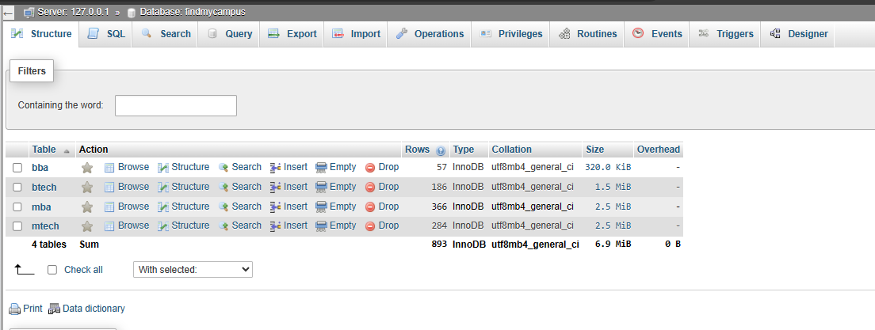

BTech table:

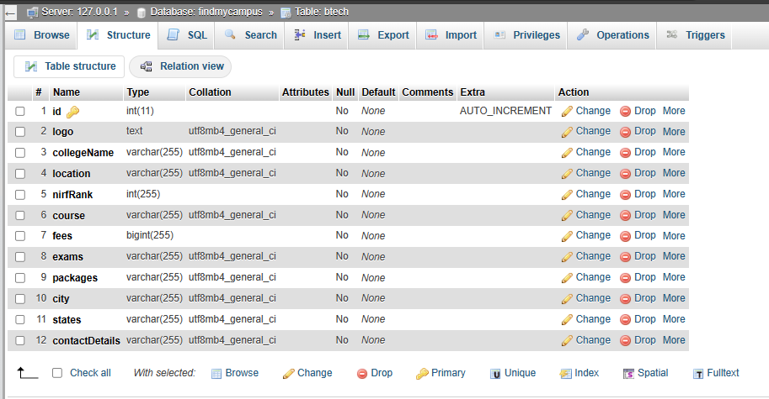

MTech table:

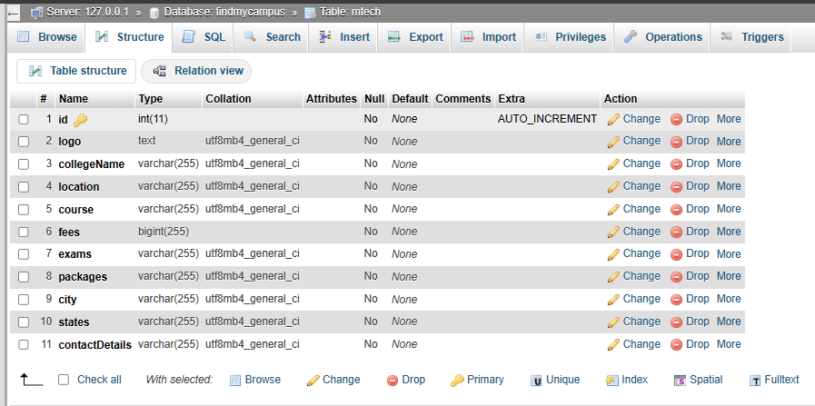

BBA table:

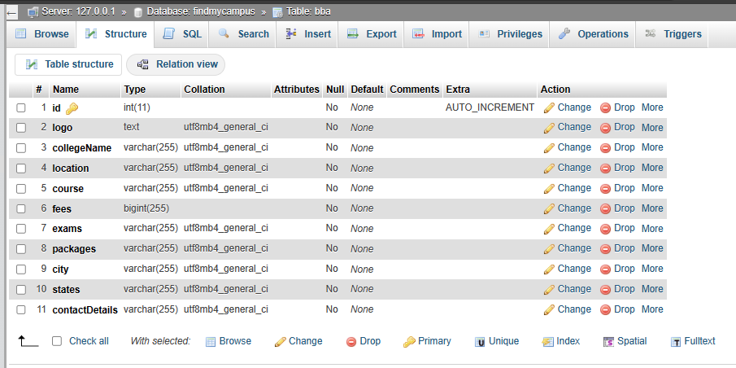

MBA table:

